Othello/ Reversi Manual

System overview
Project consists of 2 python modules
  - Components.py
Provides the game logic for
- Board creation
- Legal move decision
- Piece flipping
- Ai evaluation and decision making (For AI version)
- Board simulation for Ai
  - Flask Game Engine.py
Hosts the game engine through a flask server and provides gameplay operations over HTTP routes.

Installation instructions
System requirements
- Python 3.10 or later
- Pip (Python package manager)
- A modern Web browser
- Visual Studio Code (only if you want to modify the source code)
Project Dependencies (if not included during install)
- Flask
- Json, Random

Project Setup
Place the following files in the same project directory
- components.py
- flask_game_engine.py
- templates/index.html
Install flask
- pip install Flask

Running the Application
Starting the Flask Server
From the project directory, run
- python flask_game_engine.py
Flask will start a development server outputting an address
Open a Browser and enter the address given in the terminal.
- The game will load, and you will play as the Dark colour
- The Ai will control the light colour
- Click on a board square to make a move, This will send a move to the move route in the game engine.
- The game will alternate between the human and the Ai unless one player cannot make a move.

Backend API Reference
For Python Game Engine
/ – Main Page
- Renders the game with Current Board, Player Turn, Dark/Light scores
/move – Make a Move
- Parameters
  - X: column number
  - Y: row number
- Workflow handled by backend functions
- Returns JSON
/reset
- Initialises a fresh board
/save_game
- Writes the current board, player turn, and log to Othello_save.json
/load_game
- Load state from file and restores the session

For index HTML
Function | Purpose
sendMove (x, y, url) | To gain the input from the webpage and return to the python backend
saveLoadAction(action) | For saving and loading game file during the game
loadBoard() | For loading the board onto the webpage
Load(GameLog) | For loading the game log onto the webpage
updateMessageBox(message) | For updating the message box during the game
updateCurrentPlayerDisplay(player) | For updating the current player textbox during the game
updateScoresDisplay(currentBoard) | For updating the scores for each colour during the game.

Components Function Reference
Board Management
Function | Purpose

initialise_board(size) | Creates a standard 8 by 8 board with four starting tiles
print_board(board) | Console-formatted table output

Move Validation
legal_move(colour, coordinate, board) | Determines whether a move is legal and returns the tiles that would be flipped
get_pieces_to_flip_in_direction(board, colour, x, y, dx, dy) | Checks one direction for outflanking

Move Execution
make_move(board, colour, coordinate, pieces_to_flip) | Places a piece and flips the captured tiles

Board Evaluation
count_Pieces(board) | Counts Light and Dark pieces on the board
check_for_legal_moves(board, colour) | Checks wither a player has any playable moves
evaluate_board(board, ai_colour) | Ai scoring function based on tile majority

AI Operations
pick_ai_move(board, ai_colour) | Chooses a move by simulating all legal ones and selecting one of the top three.
get_all_legal_moves(board, colour) | Gathers all potential moves and their resulting flips
simulate_move(board, colour, move, flips  ) | Produces a theoretical board after a moved, used by AI.

Game Engine Function Reference
In Game Functions
Function | Purpose
initialise_game_state() | Initialised board and start player
get_current_board() | Returns the current board
get_current_player() | Returns the current player to play
switch_player() | Switches to the other player
check_game_over() | Checks that no move moves can be played to end the game.

Save and Load Functions #
save_game() | Saves the current game state to .json file
load_game() | Loads the saved .json file onto the webpage

Handle Game Functions
index() | For rendering the game to the webpage, loads the board and the players turn and the scoreboard
reset_game() | Used for resetting the game
handle_Move() | Used for handling the player and Ai move

Testing Appendix

- Board initialisation Test
Test Id | Action | Expected Result | Actual Result | Pass/Fail
1.1 | Board Size – start the game and Initialise a board | An 8 * 8 board is loaded onto the webpage | The board is loaded as an 8 * 8 grid 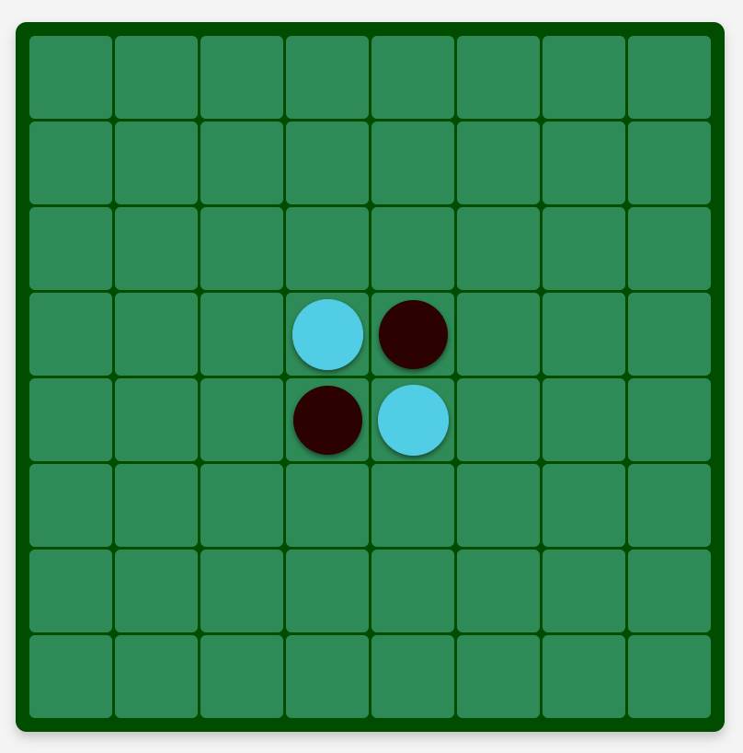 | Pass
1.2 | Initial Pieces added to the board | 2 dark and 2 light pieces should be place in the centre at coordinates 4,4 , 4,5 , 5,4 and 5,5 of the board in opposite corners | The 2 Dark and 2 Light Pieces are added to the board | Pass

- Manuel Move and Flip Tests

2.1 | Legal Move Detection – try placing a dark at 3,4 | Move is legal and the piece is placed at 3,4 | The Legal move at 4,3 successfully places a dark piece as shown in the Game Log  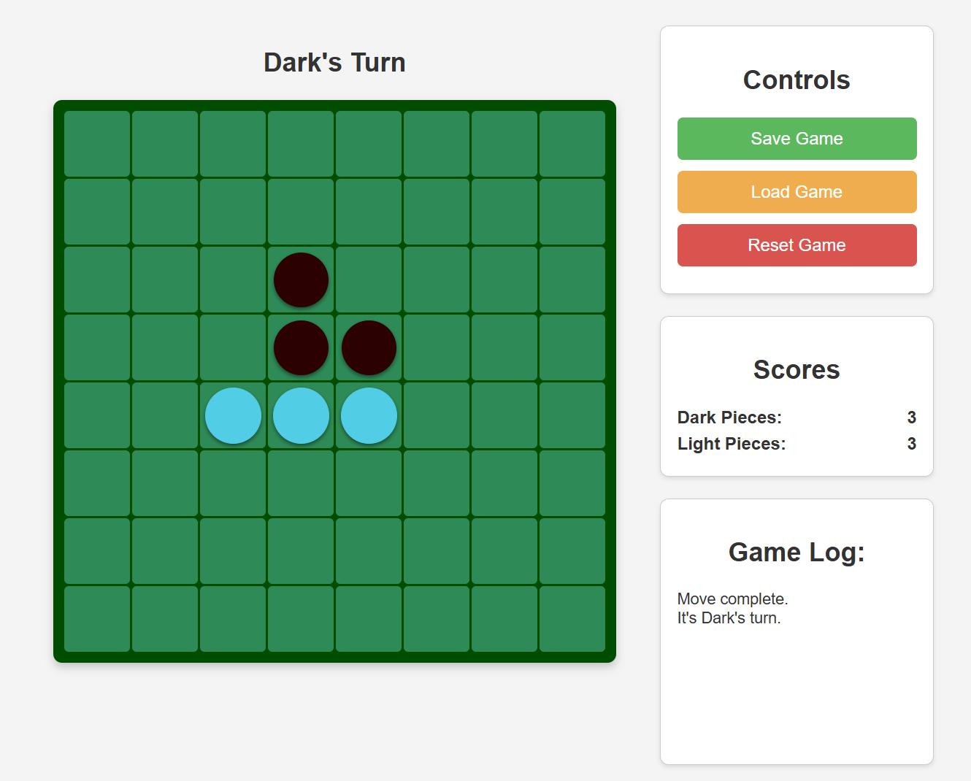 | Pass
2.2 | Illegal Move – try placing a dark at 1,1 | Move is illegal and the piece is not placed | No piece is placed and message in the Game Log states that an invalid move was received.  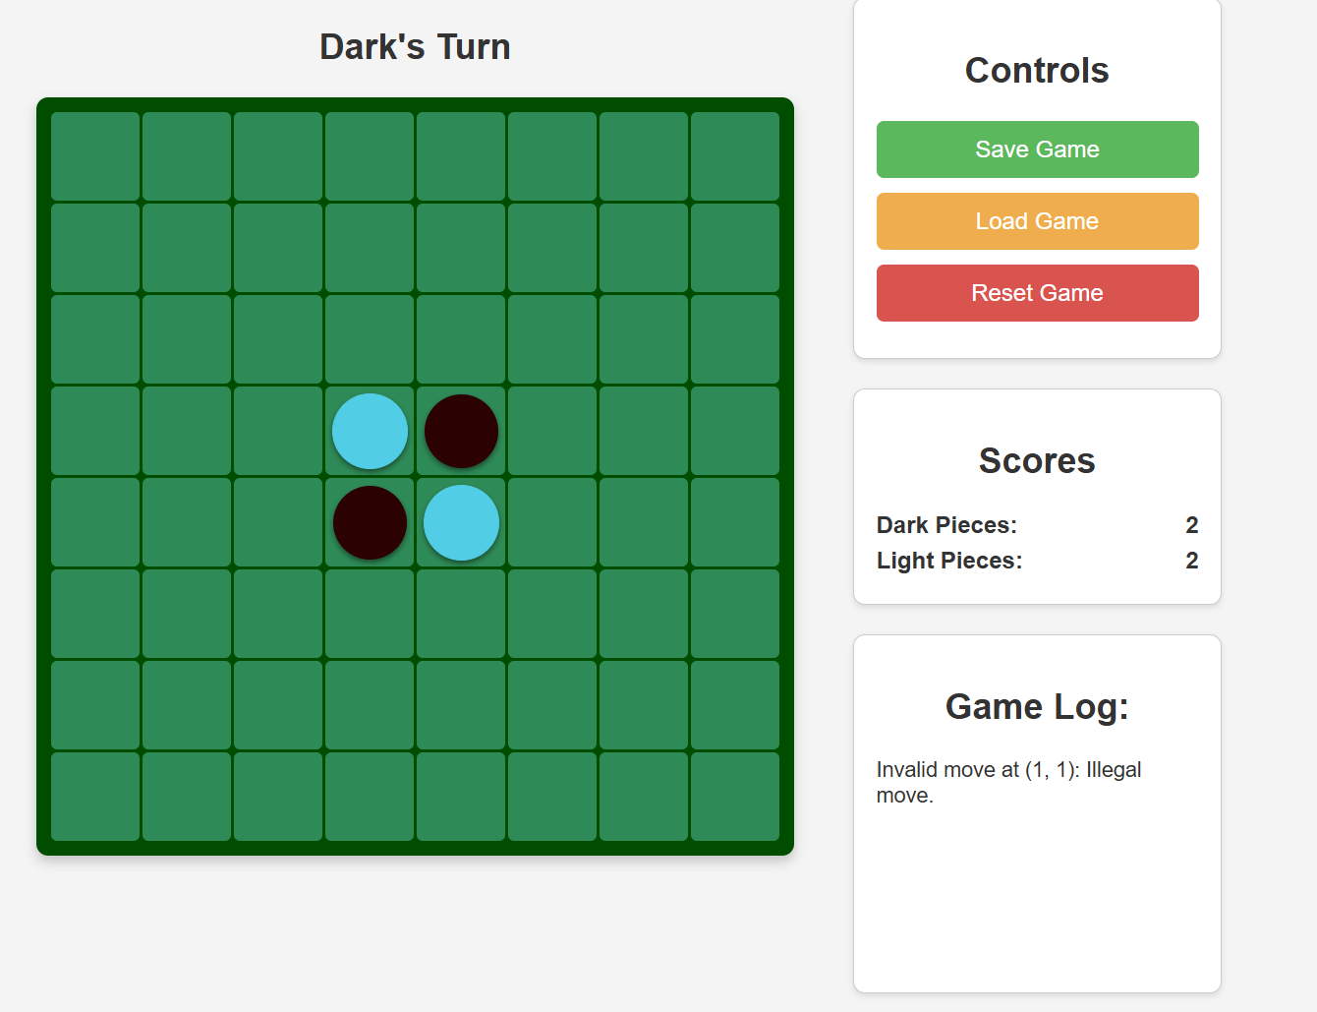 | Pass
2.3 | Piece Flipping – make a legal move at 3,4, and see if piece are flipped | Move is legal and the piece at 4,4 changes from light to dark | Move is legal and the piece at 4,4 which was previously Light has been switched to Dark showing the piece flipping is working  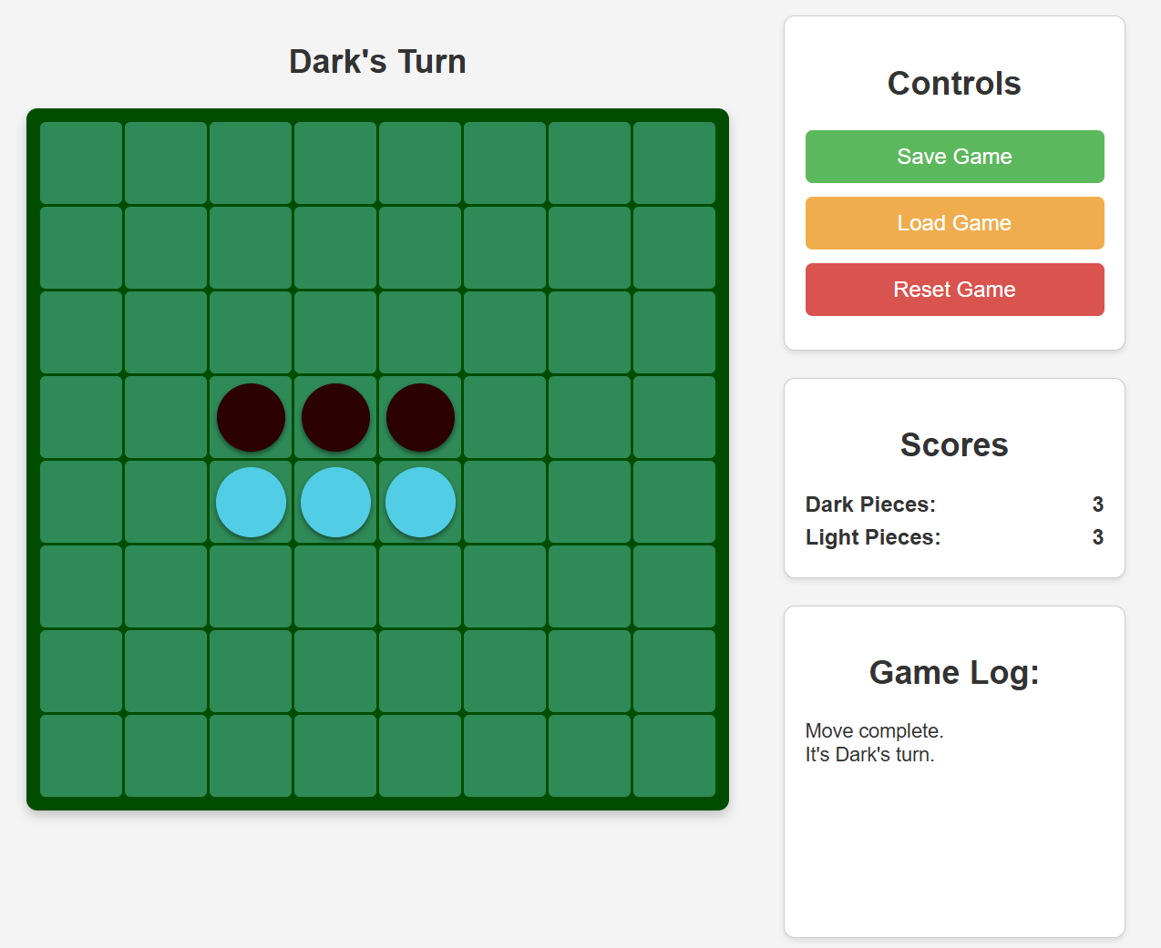 | Pass

- Turn Handling Tests

3.1 | Player Switching – Make a valid dark move and the player is switched to Light which makes their turn | Switches to Ai and the Ai makes a valid turn on the board | After Move complete at 4,3 from the human player, the game switches to the Ai turn which makes a move at 3, 5.  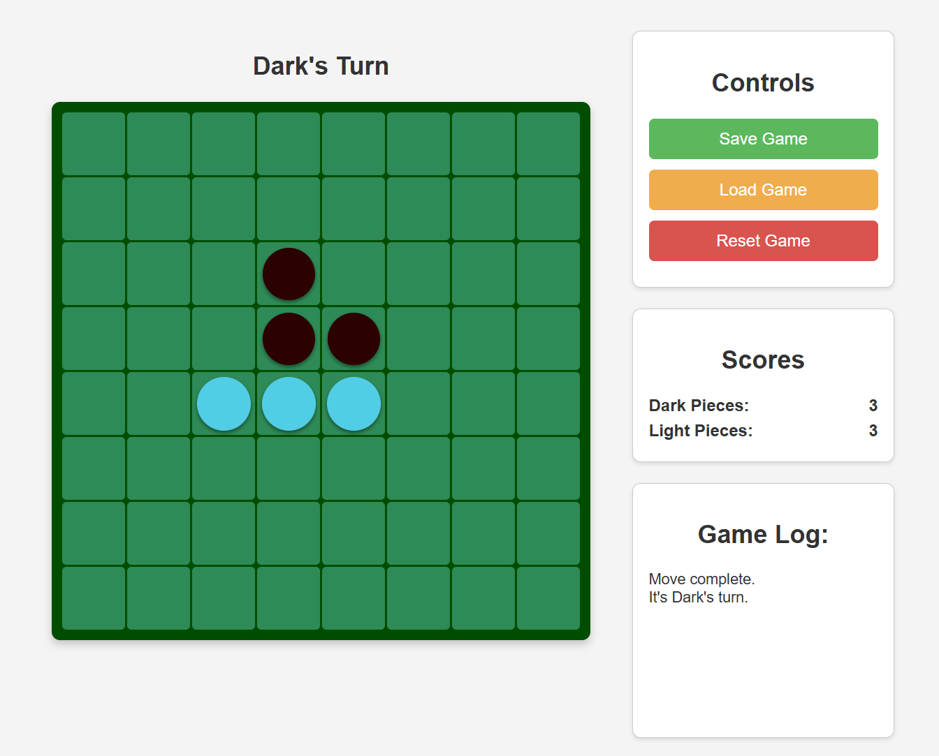 | Pass

- Ai Tests
4.1 | Ai Makes only legal moves - Play a few turns with the Ai and ensure it makes only legal moves | Ensure it never plays on occupied square and at least one piece is flipped each turn | From playing this game, following moves were made:  player at 3, 4 (legal)  ai at 5, 3 (legal)  player at 6, 4 (legal)  ai at 3, 5 (legal)  player at 3, 6 (legal)  ai at 2, 5 (legal)  player placed at 5, 6 (legal)  ai placed at 5, 7 (legal)  player placed at 1, 5 (legal)  ai placed at 7, 2 (legal)  player placed at 6, 3 (legal)  ai placed at 2, 4 (legal)  All moves made by Ai were Legal  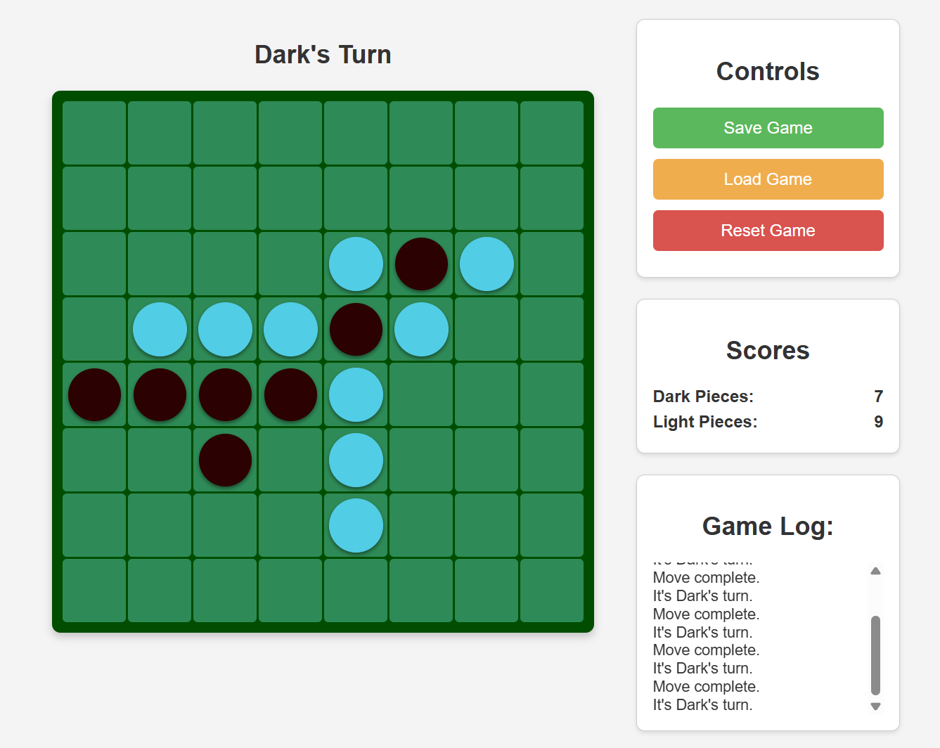 | Pass
4.2 | Ai Pass Condition – Create a scenario where light has no legal moves | Response shows AI was skipped or “passed” | When Player could make no moves, the player was passed to the Ai, and message was given to state a pass was made  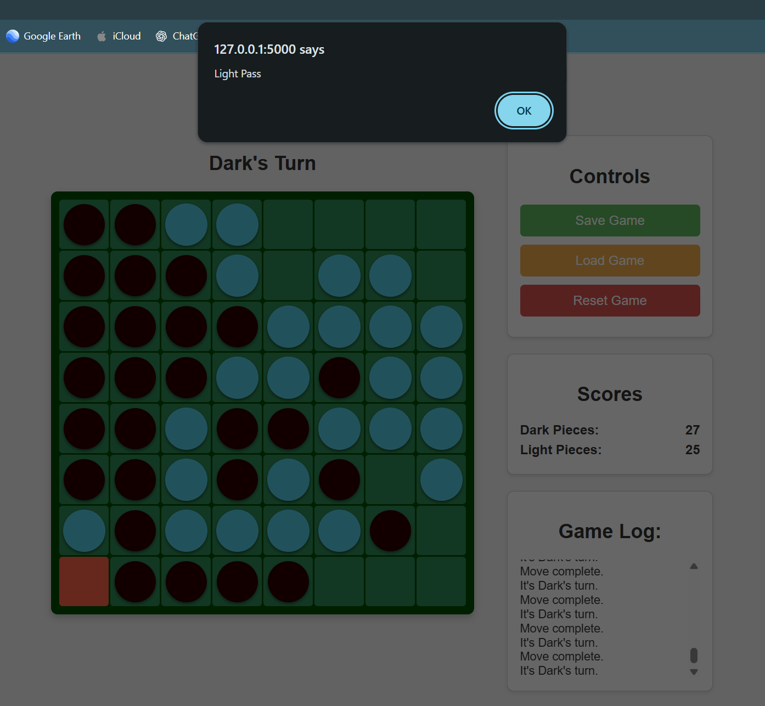 | Pass

- End-Game Tests
5.1 | One Player has no moves | Show that the current colour has been skipped | The current colour is Light and there is no move for the Dark to make therefore the Dark is passed  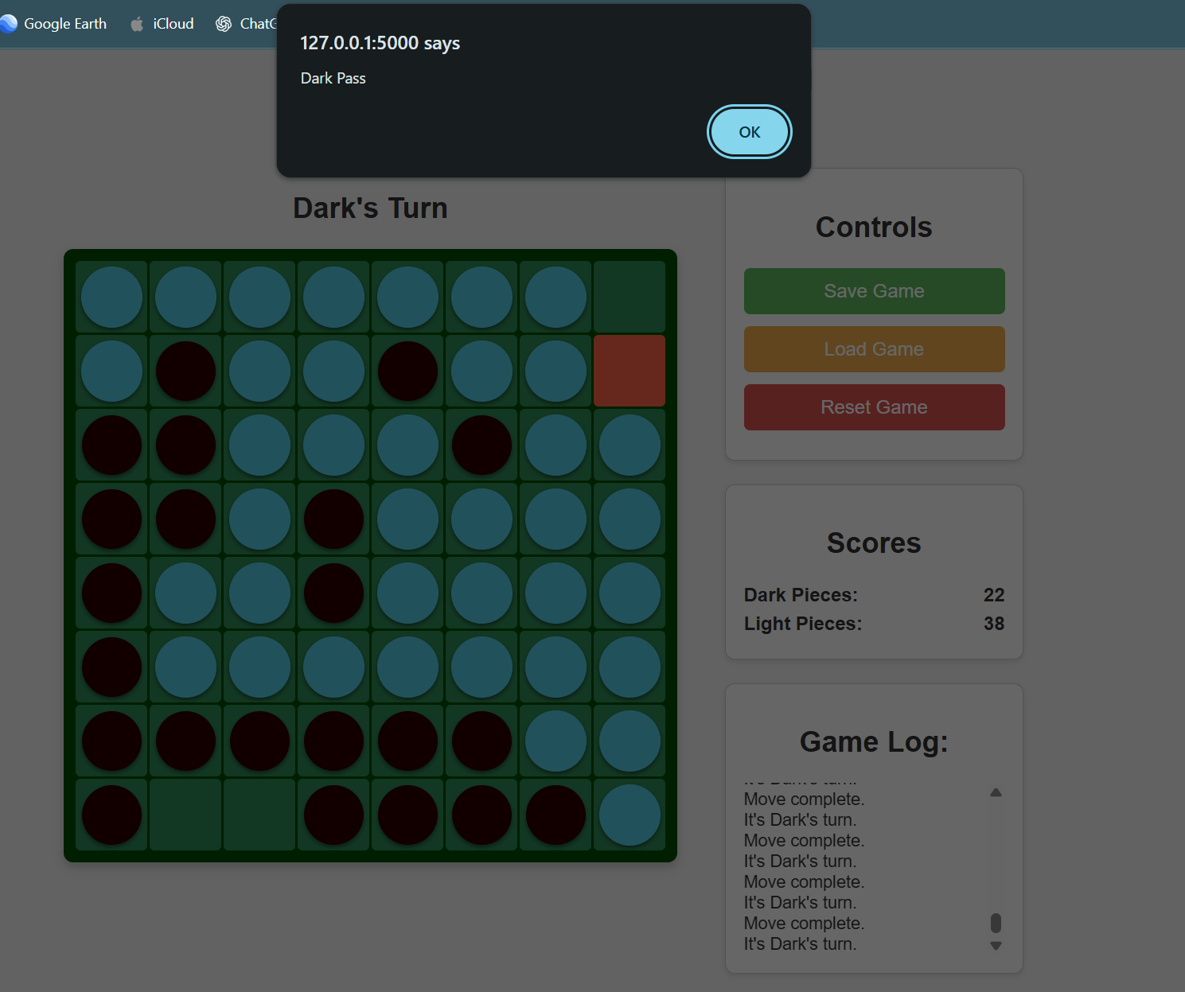 | Pass
5.2 | Neither Player Has moves | Game Returns final score and “Game Over” | There are no more legal moves for both players therefore the game ends and the winner is displayed  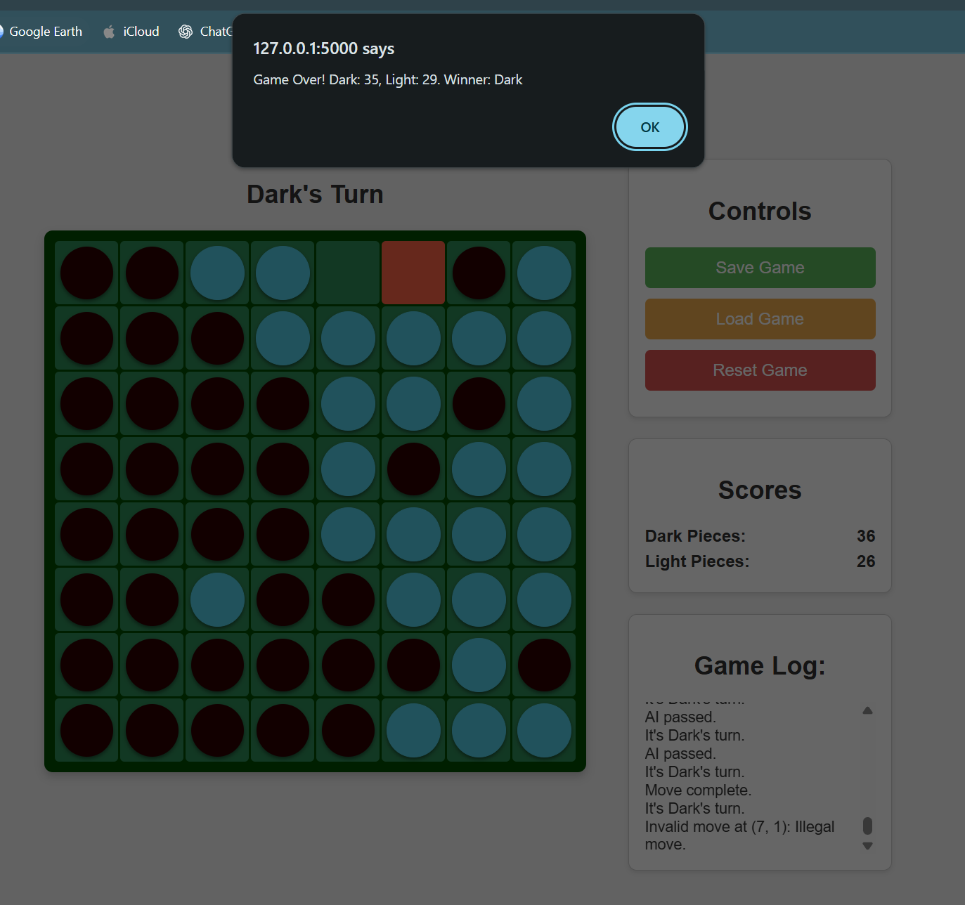 | Pass

- Save and Load Tests
6.1 | Saving – Play a few moves and click save | When played a few moves, press save and a Othello_save.json should be saved in the folder | The Game is sucessfully saved as shown in the Game Log and the file is stored alongside the source code files as Othello_save.  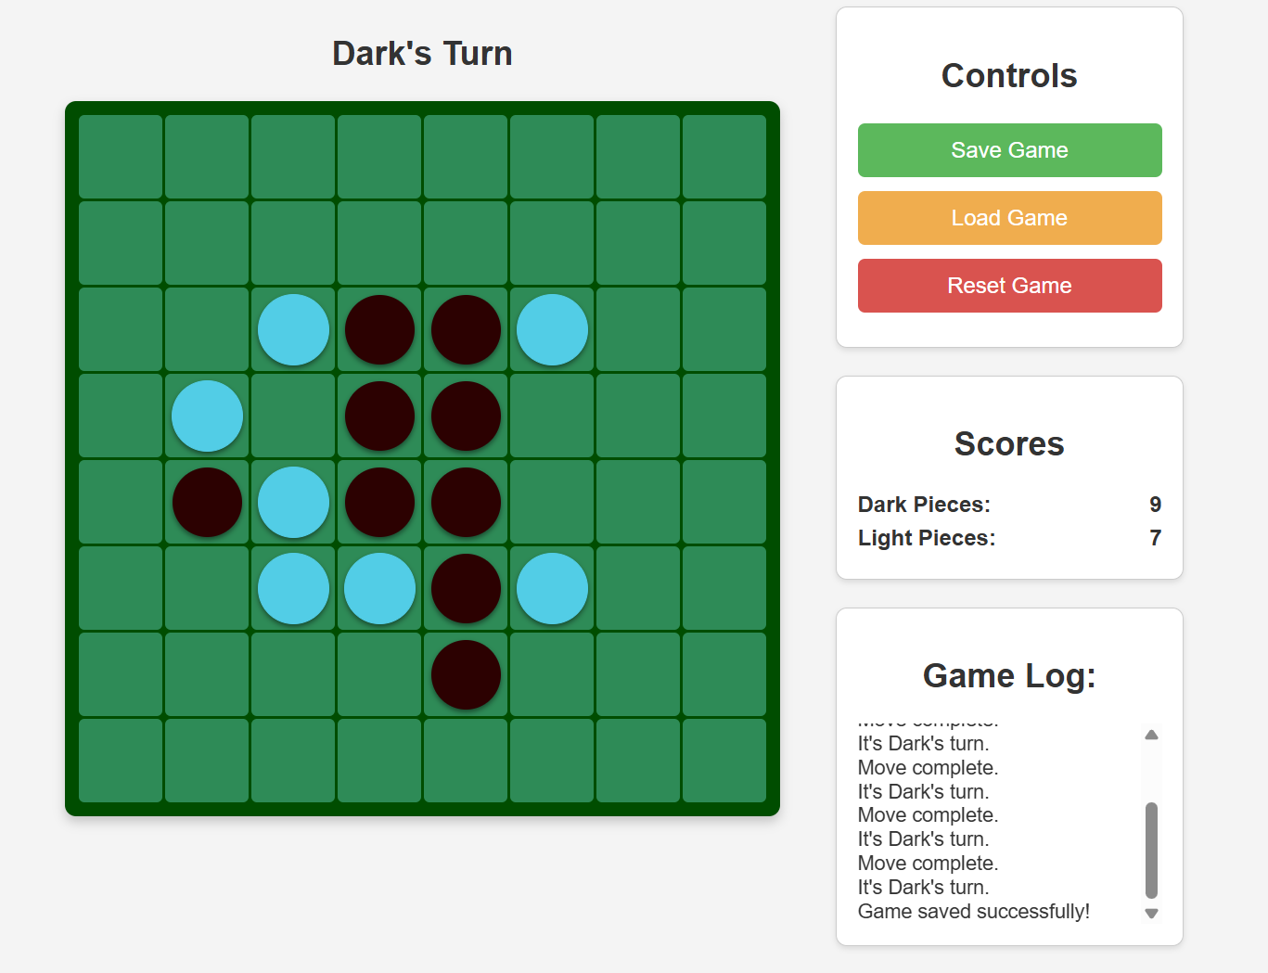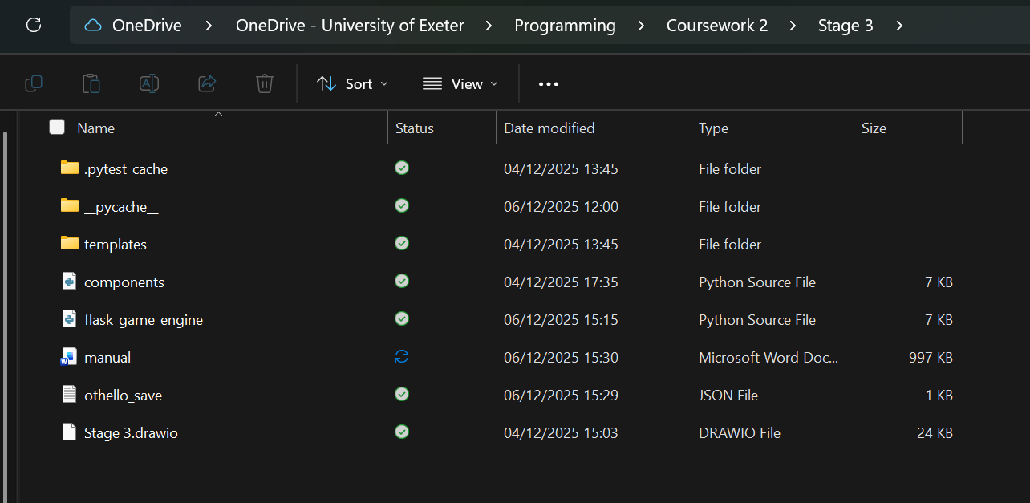 | Pass
6.2 | Loading – Load game after refreshing session | Board state is retuned exactly, and the current players turn is restored. | The board state is returned to wherever the last save, however the Game Log is not saved and re-outputted  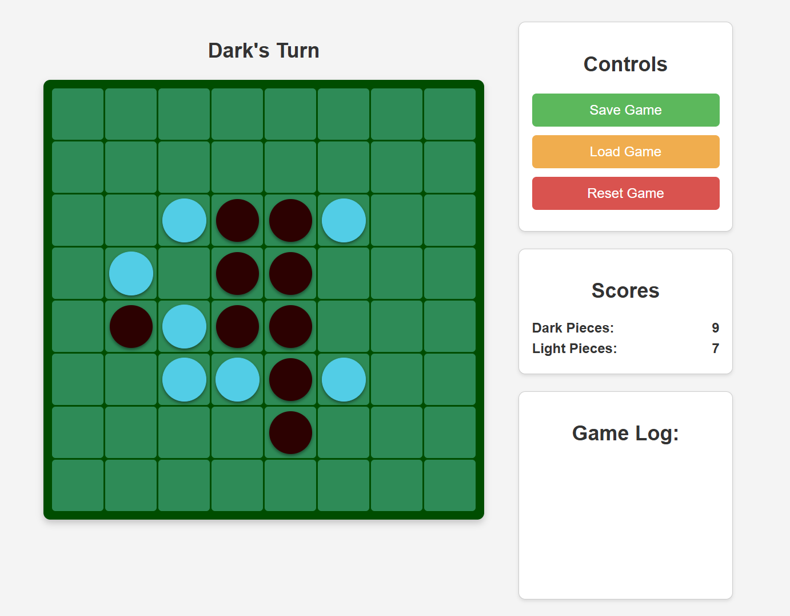 | Fail

